1. Create a new class that derives from Shape, and implement Shape’s interface. Triangle will extend from Shape and contains the contents of OTHTriangle. Triangle passes all requests made to the Triangle object to OTHTriangle.
2. 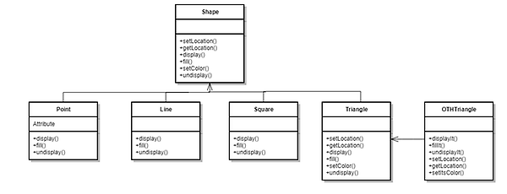
3. class Triangle extends Shape {

private OTHTriangle other;

public Triangle () {

other = new OTHTriangle();

}

void public display() {

other.displayIt();

}

}